**Date : 28.09.2022**

**Ques : compile and execute a C++ program to copy a file:**

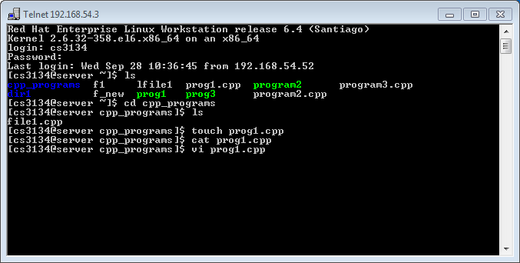

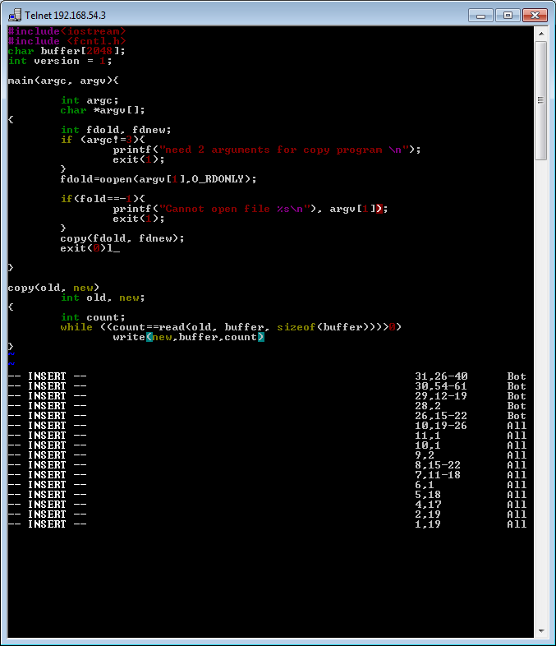

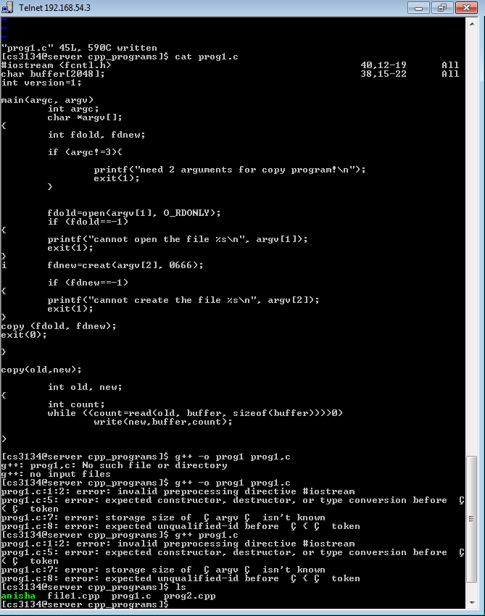

**CODE :**

**cd** shows current directory

**ls** lists the items of current directory

**ls –l**  lists the items of current directory with their details

**touch <new file name>**  creates new file in current directory

**cat <file name>**  shows the contents of new file

**vi <file name>**  opens the selected file in editor mode

**I**  enables editing in editor mode

**Esc** exits the editor mode

**:wq** saves the file and closes it

**Cat <file name>** shows the contents of the file

**g++ -o <compiled file name> <source file.cpp>** compiles the file and saves the compiled file with new name

**./<compiled file name>** runs/executes/shows contents of compiled files